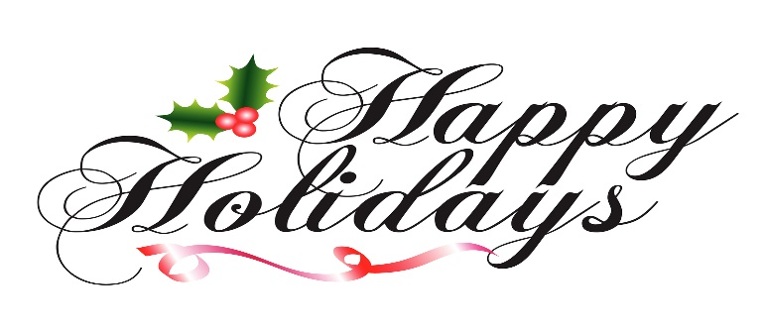

Florence Christmas Parade
Theme: "The Magic of Christmas"

TO ALL PARTICIPANTS:

It’s that time again and we know that you’re excited and ready. The Annual Christmas Parade will be held on Saturday, December 16, 2023 beginning at 11:00 AM. The parade will start on Evans Street (Old Winn-Dixie Parking Lot) and ending at the Business Technological Center (BTC) Building.

We are asking that all participants get into the spirit by decorating their vehicles or floats to center around the theme.

The parade will consist of several different categories with awards being given to our overall winners. Awards and Trophies will be presented at the judge’s location on Evans Street immediately following the parade. If you must leave before the conclusion of the parade, please have a representative available to receive the award.

Participation fees support the continuation of the Christmas Parade. There will be a fee of $70.00 per unit; anything over 4 units (in one group) there will be a flat fee of $100.00. Please make check payable to: The Florence Christmas Parade Committee. All applications and fees must be received by December 8, 2023. If you have any questions please contact Mrs. Courtney Allison at 843-617-9464.

Sincerely,

Christmas Parade Committee

The Florence Christmas Parade
3654 Westpoint Drive
Florence, South Carolina 29501
(843) 621-0001

